**JDBC AND MS Access**

**Step 1 Open Access**

**Create Database File named: MyData.accdb**

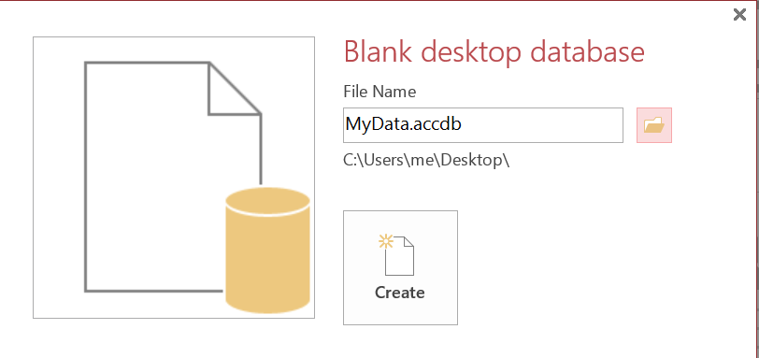

**Save to Desktop**

**Step 2 Create Database Table**

**Access Menu: [ Create ] -> [Queries ] group -> [Query Design] link**

**Close Show Table dialog box**

**Click SQL view**

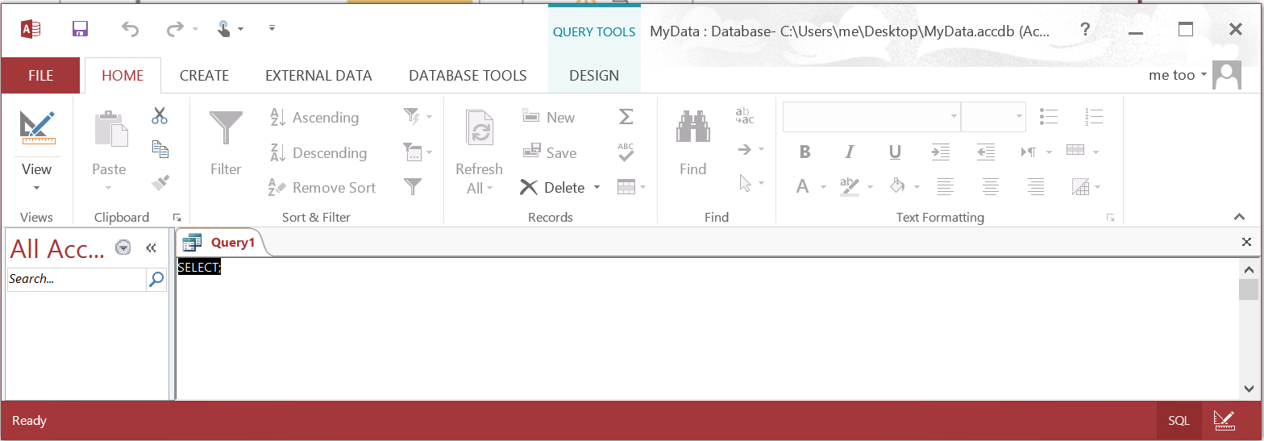

**Execute the CREATE Table script**

**CREATE TABLE students**

**(**

**RollNo Integer NOT NULL,**

**SName CHAR(25),**

**GPA DOUBLE,**

**PRIMARY KEY (RollNo)**

**);**

**Run Query [ ! ]**

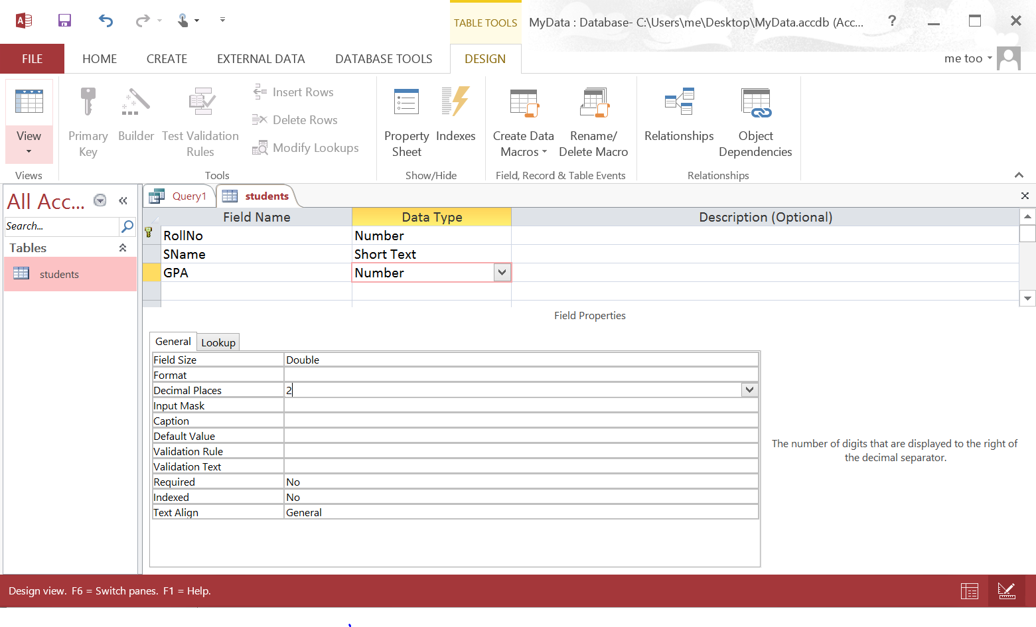

**Set Decimal Places (Fixed) to 2 for the GPA field**

**Close Table but keep Access open**

**Step 3 Populate Database Table**

**INSERT INTO students (RollNo, SName, GPA)**

**VALUES (101, 'patel', 3.20);**

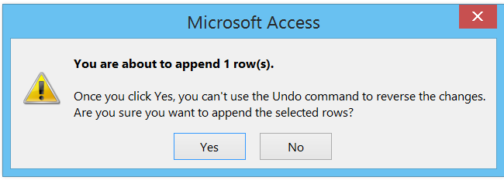

**INSERT INTO students (RollNo, SName, GPA)**

**VALUES (102, 'singh', 3.10);**

**INSERT INTO students (RollNo, SName, GPA)**

**VALUES (103, 'smith', 3.45);**

**INSERT INTO students (RollNo, SName, GPA)**

**VALUES (104, 'pappas', 2.25);**

**INSERT INTO students (RollNo, SName, GPA)**

**VALUES (105, 'diaz', 4.00);**

**Step 4 Observe Access Datasheet**

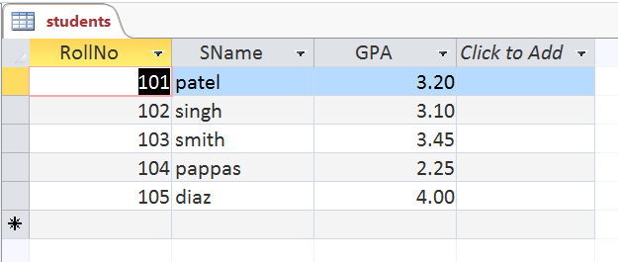

**Step 5 Create Java Application**

**Eclipse - > New Java Project -> JDBCAccessDemo**

**Source Code:**

|  |
| --- |
| **import** java.sql.*;  **public** **class** JDBCAccessDemo  {  **public** **static** **void** main(String[] args)  {  **try**  {  // loading the jdbc odbc driver  Class.*forName*("sun.jdbc.odbc.JdbcOdbcDriver");  // creating connection to the data base  Connection con = DriverManager.*getConnection*("jdbc:odbc:mydsn","","");  Statement st = con.createStatement();  // create an execute sql command on database  ResultSet rs = st.executeQuery("Select * from student order by rollno asc");  ResultSetMetaData rsmd = rs.getMetaData();  // this getColumnCount return the number of column in the selected table  **int** numberOfColumns = rsmd.getColumnCount();  // while loop and with while loop code use for print the data  **while** (rs.next())  {  **for** (**int** i = 1; i <= numberOfColumns; i++)  {  **if** (i > 1)  System.***out***.print(", ");  String columnValue = rs.getString(i);  System.***out***.print(columnValue);  }  System.***out***.println("");  }  st.close();  con.close();  } **catch** (Exception ex)  {  System.***err***.print("Exception: ");  System.***err***.println(ex.getMessage());  }  }  } |

**Project Saved to**

**C:\Users\me\workspace**

**Notice: mydsn is the name of our Data Source object for connection purposes.**

**Notice: database table name is students**

**Step 6 Move Database File to Java Project Folder**

**Eclipse - > New Java Project -> JDBCAccessDemo**

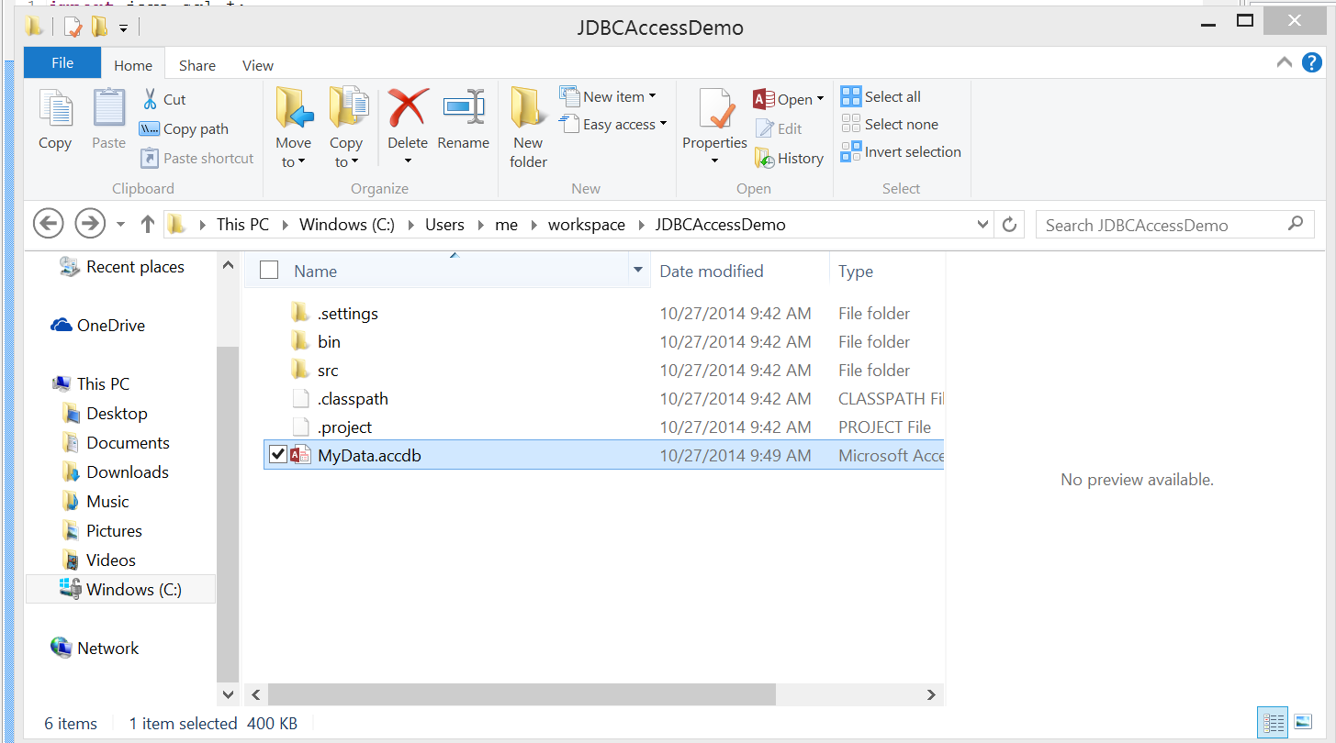

**C:\Users\me\workspace\JDBCAccessDemo**

**Step 7 Configure ODBC**

**Open Database Connectivity ( ODBC )**

**Control Panel -> System and Security -> Administrative Tools**

**Select [ ODBC Data Sources (64-bit) ]**

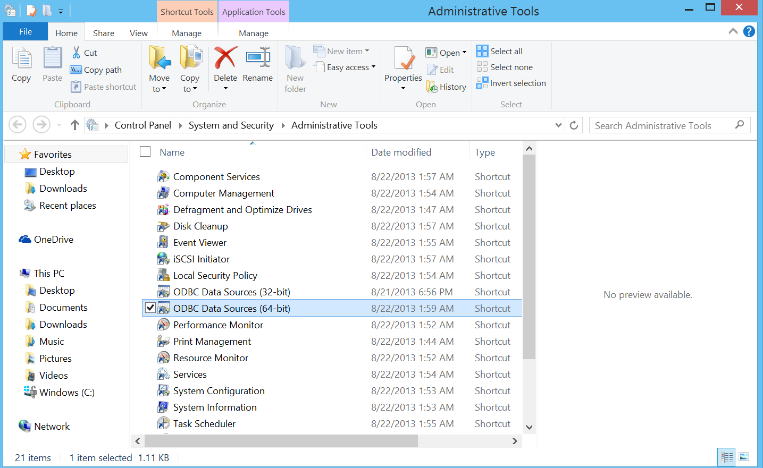

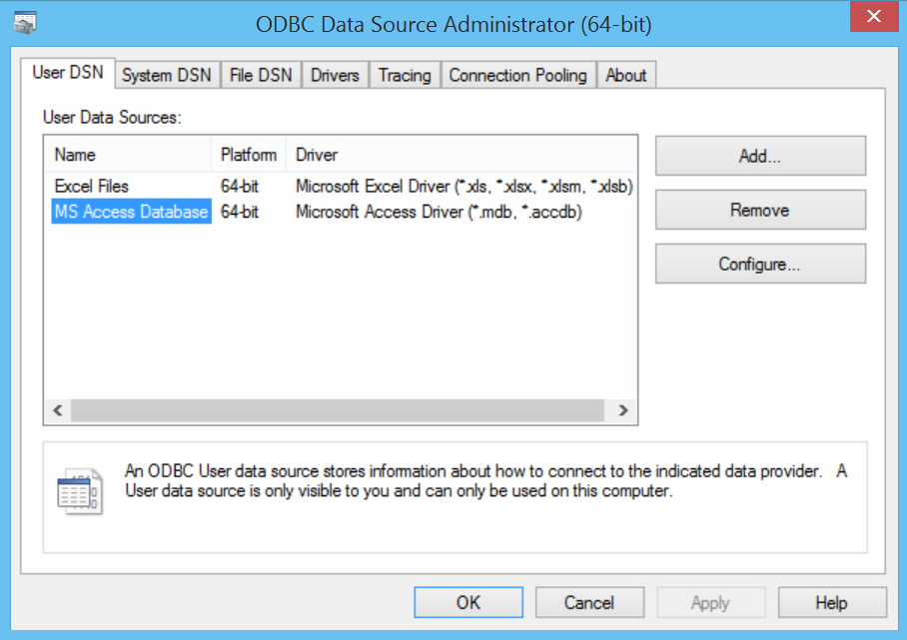

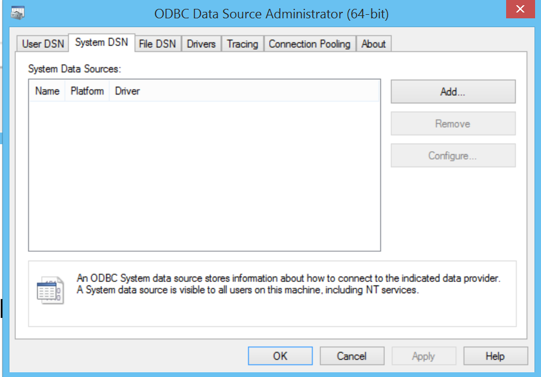

**Click [ System DSN ] tab and click [ Add ]**

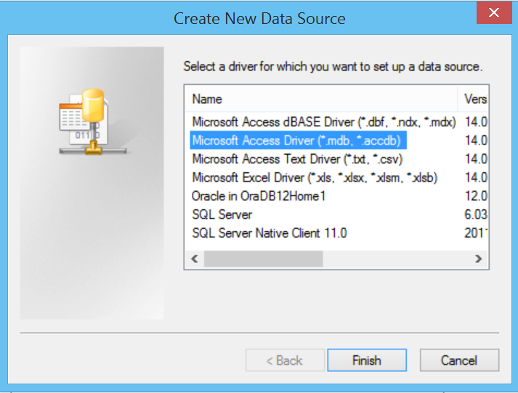

**Select Microsoft Access Driver (*.mdb, *.accdb)**

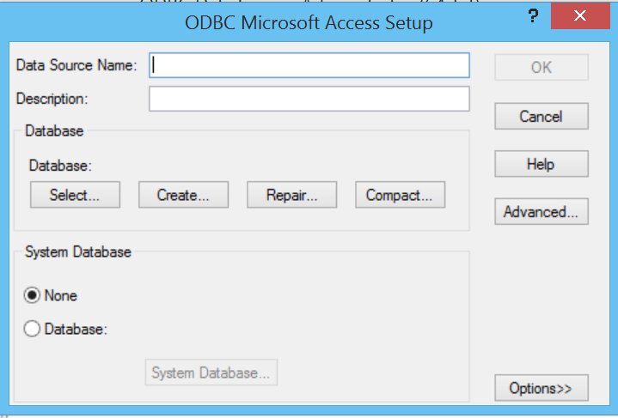

**Data Source Name: mydsn**

**Select Database**

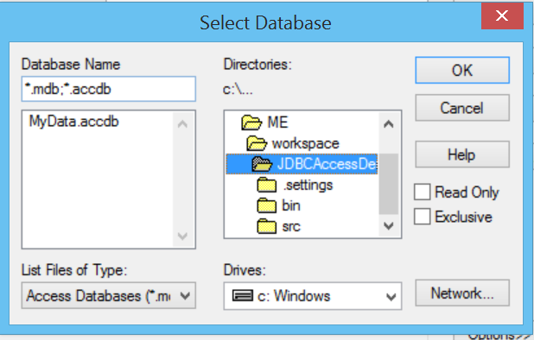

**Configuration Complete**

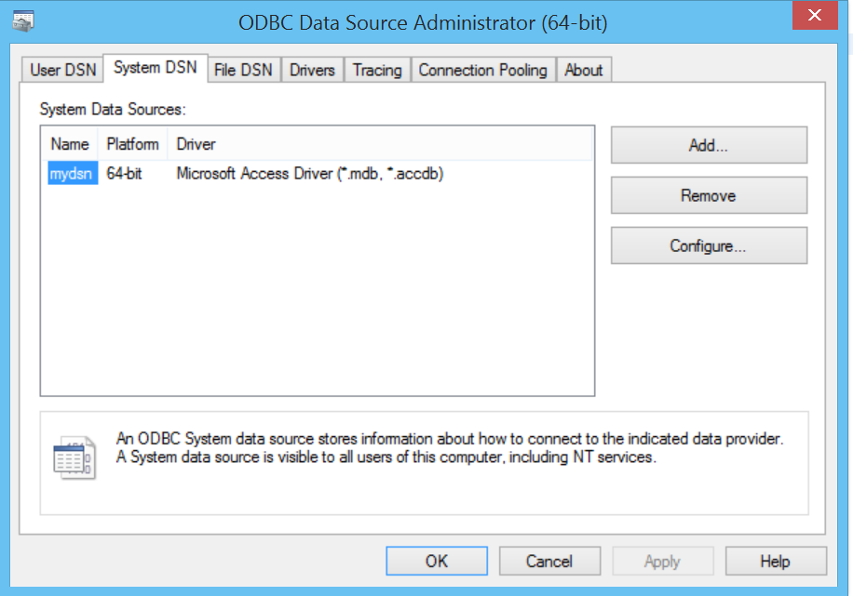

**Note:**

**Download 64 bit ODBC if not available**

**64-Bit OLEDB Provider for ODBC (MSDASQL)**

[**http://www.microsoft.com/en-us/download/details.aspx?id=20065**](http://www.microsoft.com/en-us/download/details.aspx?id=20065)

**Step 8 Run JDBC / ODBC / MS Access Java Application**

**Observe output in Java IDE**

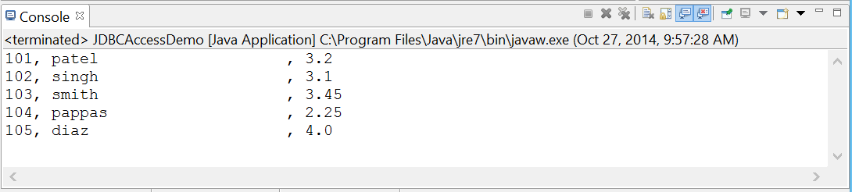

**Step 10 Observe MS Access Record - Locking File**

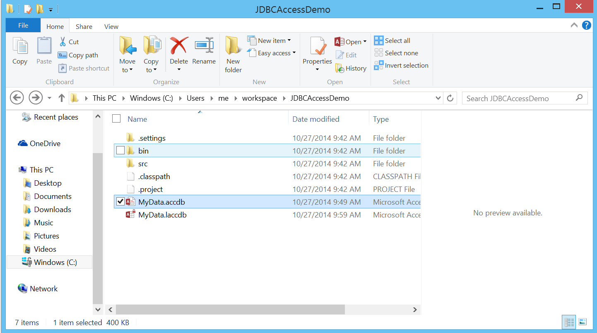

**Step 11 Observe Error Messages Generated by Program Application**

**Database table name in source code not matching table name in database file:**

Exception: [Microsoft][ODBC Microsoft Access Driver] The Microsoft Access database engine cannot find the input table or query 'student'. Make sure it exists and that its name is spelled correctly.

**Data Source Name in ODBC differs from that shown in Java source code.**

Exception: [Microsoft][ODBC Driver Manager] Data source name not found and no default driver specified